VBoard

Virtually Interactive Board

By Ajay Singh

Index

|  |
| --- |
| 1. Introduction. |
| 1. System Analysis And Problem Description |
| 1. Need Of A New System. |
| 1. Design. |
| 1. Flow Of Control. |
| 1. Prerequisite. |
| 1. Hard And Software Used. |
| 1. Conclusion. |

Introduction

* VBoard is an application which lets you interact with the screen of your device.
* It requires a device capable of emitting light, bright enough for the program to be able to detect and a camera to observe it.
* It works on the concept of Computer Vision (C.V).
* It mainly involves color detection, shape detection and object detection.

System Analysis

And

Problem Description

In this section we will how the existing system works.

* Any system that promises virtual features

today either includes a stylus or the use of fingers while physically interacting with the board.

* While providing barely what a pure virtual

system should provide. It cost substantial

amount of money to install it in the workplace.

* These systems often include hardware which fragile in nature and difficult to move from one place to another. While virtual means limited amount of very easily portable hardware.
* Even after installation it requires specialized person to operate these systems making it very complicated for the masses.

From above analysis of the existing options, we can define limitation which comes with it:

* Barely virtual: While the existing systems do provide virtual features but it often requires the user to come near to the hardware to be able to use it.
* Installation cost: Beginning cost of these systems are often high as compared to some open-source projects which incurs little to no expense.
* Hardware issues: Available options in the market often includes purchase of hardware which are fragile in nature or difficult transport. It violates the virtuality.

Need Of A New System

Below are some reasons for the need of

a new system:

* Proper virtual: A system which provides proper virtual way of using the itself without any sort of interaction.
* Installation cost: In the new era of open-source one need to only procure the application and required devices to use it with negligible cost.
* Hardware: Pure virtual systems like this often requires only the pointers as a device to virtually interact with the board and these pointers are very portable and durable.

Design

* Program works on basic concept of color and shape detection.
* It Implements methods such masking to detect colors and shapes of the pointers.

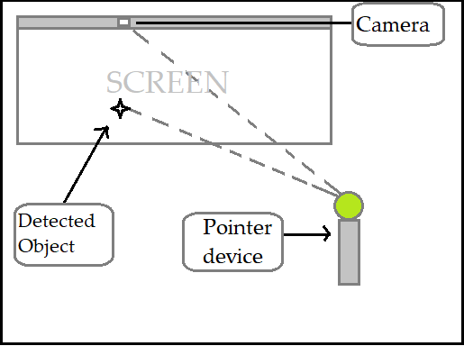

* It implements all the functions such as grading and masking at the backend and displays the position of object on a 650x540 canvas zoomed in to fit the screen of any device capable of running the application.

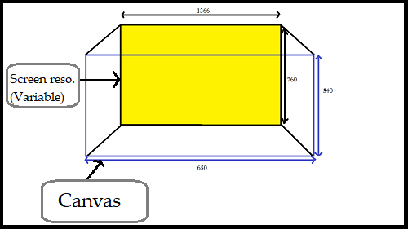

* Coordinates of the detected object is exponential on the screen as compared to that on the canvas.
* Being exponential for the screen of the device, an object may appear at different position for screen and the canvas.

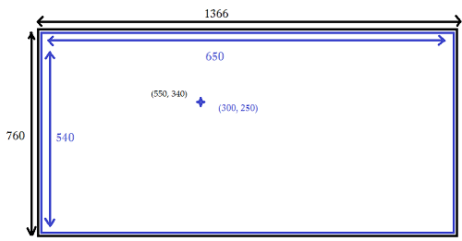

* The z-index of the stack is 0.

Flow Of Control

Prerequisite

* First condition is to have a device with a camera to detect the object.
* Second condition is to have a object capable of emitting bright light of any color.
* Extra tip: The application works best in a dark room with a projector.

Hardware And Software

Used

Conclusion

VBoard is the output of 60+ hours of work done by a single developer.

It has begun as an intermediate object and in the near future, it will come with more features and better UI.

Thank you for reading this document.

Your time is highly appreciated.